Representation, Advisory, Pastoral

Worcestershire LMC Position Statement: Draft Service Specifications for the Network DES
09 January 2020

Draft service specifications for the PCN Network DES were published on 23rd December and as a result many GPs have spent their Christmas holidays reviewing them. NHS England have requested that all stakeholders submit a response to the draft specifications by 15th January through an online survey. Worcestershire LMC has completed the survey and local GPs have been encouraged to give their views. A strong message needs to be sent to NHSE before formal negotiation with the General Practitioners Committee (GPC) on the draft service specifications. The link to the document and survey is here.

It is our view that these draft specifications are unachievable based on the current workforce, lack of capacity and lack of any additional resource. The workload detailed in the specifications means that the new additional roles are unlikely to be enough to stabilise general practice. If practices are to contribute to additional staff salaries, they must be able to see a benefit for their local population and general practice sustainability.

The draft service specifications must therefore be rejected in their entirety and negotiations begun with GPC. Any new service specifications must recognise the need for significant investment in to general practice and be cognisant of the current pressures facing general practice both in terms of workforce and workload. Without a realistic approach at this point, there is a significant risk that Primary Care Networks will fail and colleagues will have no choice but to withdraw from the Network DES entirely.

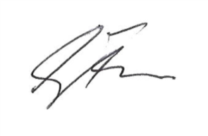

Dr Shaun Pike Dr Gillian Farmer
Worcestershire LMC Chairman Worcestershire LMC Secretary
Tel. 01527 65082 Tel. 01527 65082

